June 14, 2021
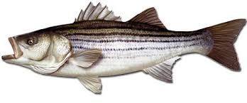
Mid-Shore Fishing Club

President – Tom Wilkison Reefball Coordinator – Bud Connors Vice President – Steve Schneider Scholarship Foundation – Steve Schneider Treasurer – Christy Helgason Raffles Committee –Don Rollyson
Webmaster – Bob Lawrence Club Fishing Tournaments Committee
Membership Committee –vacant – Chuck Prahl Christy Helgason Helmar Helgason
Guest Speakers – vacant Club Fishing Trips – vacant (looking for volunteer)
Flea Market – Harry Miller Tom Wilkison
Board Members- Tom Wilkison, Steve Schneider, Christy Helgason, Bob Lawrence, Harry Miller (n/v),
Steve Spellman, Rob Hardy, Bud Connors

NEXT MEETING June 17, 2021 7:00 PM at Elks Lodge #1272 Cambridge, Md. 21613

The Mid-Shore Fishing Club is dedicated to protect and preserve the rights and traditions of the recreational fisherman
__________________________________________________________________________________________________
April Meeting
April’s meeting was called to order at 7:00. There were 23 attendees. Bob Strakes brought in a birthday cake for Chuck P. (19 years old…I get dyslexic occasionally) We sang Happy Birthday. The cake was great. Jay R. is doing good things with out facebook page. Keep in mind, if you like the page, you can make entries.

Fishing Report

Flea Market
Flea Market went well. We made (cttm) which was just fine considering existing conditions. All the vendors were happy and looking forward to next year. Thanks to all who donated for the club table, it was a success. About half our proceeds were generated by those sales.

Club Trips
May 22 Seabass trip…sign up with the Angler…subsidized
June 5 trolling for rock out of Oxford…call Tom 410-404-3426 subsidized
June 25 live lining for rock out of Kent Island closed
August and September Cobia trips…folks will sign up (call Tom) and 6 names with be drawn from sign up list…subsidized
Augusts trips (2nd & 9th ) with Kevin Josenhans 3 anglers @ trip out of Crisfield July drawing winners eligible 1 trip only…subsidized
October trips (2nd & 16th) with Kevin Josenhans 3 anglers @ trip out of (choice) September drawing winners eligible 1 trip only..subsidized
Treasurer’s Report
We have (cttm) in our regular account and (cttm) in our scholarship fund account.
Election of Officers
Our club officer’s terms expire at the end of this year. If you have an interest at serving as club president, vice president, recordingsecretary (webmaster) and/or treasurer please let Tom Wilkison (410-404-3426 ) know so your name can be placed in consideration for our fall election.
Reef Balls
We have 41 reef balls ready to deploy. Chaney expect their renovations to be complete by 5/7 so once we strip and reform the last 4 reef balls they will be able to pour again. At April’s meeting there was the beginning of discussions about forming a partnership with multiple organizations, CBF, CCA, etc about getting reef balls deployed, including ours and some that Chris Powell has. More to come on this
Tournament Fishing
If you hear of a tournament that may be of interest to our members, let me know and I’ll spread the word via email.

Guest Speakers
April’s speaker was Chris from Big Bass USA kayak and canoe sales. Interesting presentation about sizes and styles. There is a kayak or canoe for everyone.
We are looking for someone to take control of finding speakers for our meetings. If you have any ideas for a speaker or a topic, please let us know. If there is a speaker you would like to hear, please let us know (with that speakers contact info). Respond to this email with your wishes
Year Long Fishing Contest
Rock Fish 49” Guy Edgar IV
Crappie 15” Guy Edgar IV
Catfish 44” Guy Edgar IV
Chain Pickerel 23 ¾” Tom Wilkison
White Perch 13 ¼” Guy Edgar IV
Largemouth 17 3/4” Steve Schneider (picture in a couple of weeks)
Hickory Shad 17” Chuck Prahl
Brown trout 13” Joe Opalski
Flounder 22 5/8” Hilmar Helgason
Yellow Perch 11 ½” Joe Opalski
Blue gill 8 5/8” Steve Spellman
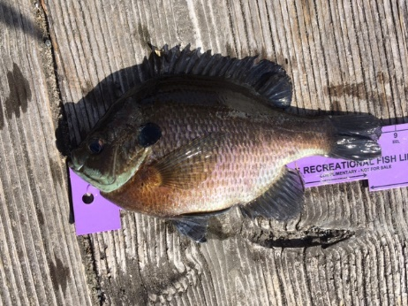
blue gill Steve Spellman

Dues
Folks, dues are due at the beginning of the year. I have attached the form, just fill it out and send your dues in. Its easy, all you have to do is do it.

Up Coming Events
MSFC monthly meeting May 20th Elks Club 7:00 pm
Luncheon June 3rd. noon Riverview at the Point
Kid’s Fishing Derby August 7th Long Wharf Park
see club trips above

Sponsors and Patrons
Folks, thank you for your support. We hope you continue this year. There is a place to do so on our membership application which is attached to the email that delivered this newsletter.

Patrons
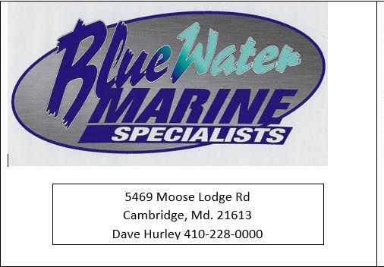 | 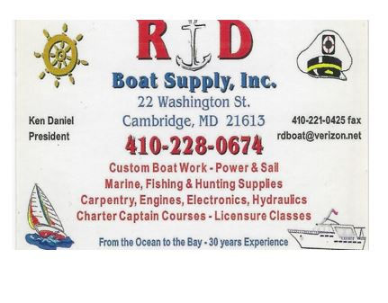 | 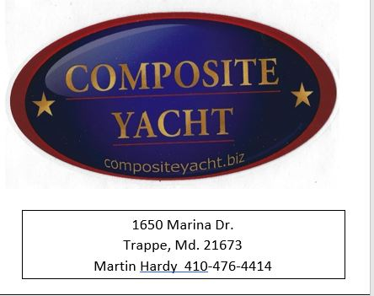
 | 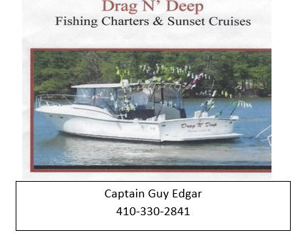 | 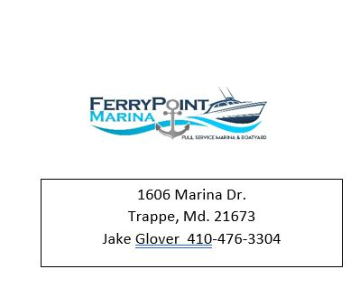

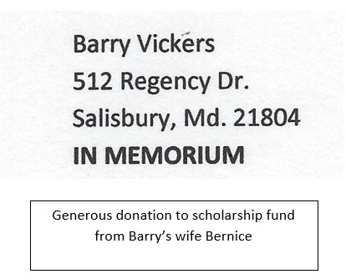

Sponsors

Windy’s Upholstry  Mark Windmiller  219 Linthicum Ave.  Cambridge, Md. 21613  410-330-3056 | Tom & Debbie Cohee  Easton, Md. | J&L Services  (Jim & Hazel Burt )  General Contractor  Galestown Md 21659  410-943-3355
Robert Higgins
Trappe, Maryland

