0March 14, 2021
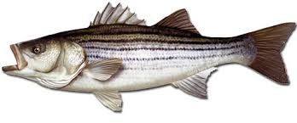
Mid-Shore Fishing Club

President – Tom Wilkison Reefball Coordinator – Bud Connors Vice President – Steve Schneider Scholarship Foundation – Steve Schneider Treasurer – Christy Helgason Raffles Committee –Don Rollyson
Webmaster – Bob Lawrence Club Fishing Tournaments Committee
Membership Committee –vacant – Chuck Prahl Christy Helgason Helmar Helgason
Guest Speakers – vacant Club Fishing Trips – vacant (looking for volunteer)
Flea Market – Harry Miller Tom Wilkison
Board Members- Tom Wilkison, Steve Schneider, Christy Helgason, Bob Lawrence, Harry Miller (n/v),
Steve Spellman, Rob Hardy

NEXT MEETING March 18, 2021 7:00 PM at Elks Lodge #1272 Cambridge, Md. 21613

The Mid-Shore Fishing Club is dedicated to protect and preserve the rights and traditions of the recreational fisherman
__________________________________________________________________________________________________
Chapter Eternal
Robert Feezer, our Board of Director at large, and our Christmas Dinner chairman passed away February 27th. He was a good club member, and a good fishing buddy. He will be missed by all. His kids hosted a wonderful “ Celebration of Life” at the Elks Club March 6th. Donation in Rob’s name can be made to Mid-Shore Fishing Club, PO Box 514, Cambridge, Md. 21613 or the Coastal Hospice Foundation, PO Box 1733, Salisbury, Md. 21802.
No February Meeting
We had no February meeting because of inclement weather.

Fishing Report
Crappie fishing on the Pocomoke above Snow Hill has been excellent. The yellow perch fishing has been good, but is starting to wane. Expectations are better if the weather warms a bit. Pickerel fishing is good. A 24”er was boated from Johnson’s Pond in Salisbury. Rick Gorleski caught 2 in the Pocomoke, in the 20” range. White perch fishing is picking up. According to Lenny Rudow’s Fishing report, “Pre-season catch-and-release striper anglers are reporting a good amount of success in the Middle Bay, jigging and in a few cases kayak trolling. Most of the fish caught this week weren’t huge with 20- to 30-inch fish being the norm, decent numbers (but no biggies) at the powerplant, and also one report of a 42-incher and a 36-incher from an angler C & R trolling single-hook, crimp-barbed tandems in the vicinity of Chesapeake Beach. “

Flea Market
Folks, our flea market is April 17th. If you are interested in a table ($30) contact Tom Wilkison 410-404-3426. Also, start thinking about your extra tackle or unwanted stuff (no junk) that you can donate to the club and we’ll sell at our Club Table. It’s a good fund raiser for us. Tom and Bob put up signs along Route 50 today advertising the date. Tell you friends and neighbors. Hopefully we’ll have a great turnout.
Club Trips
The Boys had a great trip. Bobby Granados, Rick Gorleski, and Don Rollyson had an outstanding day on our first club trip. They caught a bunch of nice crappie, yellow perch and a couple of pickerel. They had to work at it as it was blowing pretty good with gust hitting 24. Still a great trip.
At this month’s meeting, we will draw names for a spring trophy trip with Guy Edgar aboard the “Drag n Deep”. Names will be drawn from our attendance bucket. 5 names of lucky folks ( members in good standing) will be drawn. The club will pick up the majority of the cost. The winners will be responsible for a small percentage plus tip. Keep in mind, our attendance bucket is emptied December 31st of the previous year, so only member in attendance so far this year will be eligible to have their name’s drawn. Come to the meeting and sign up, it’s the white ticket. Put your name on it and drop it in the can.
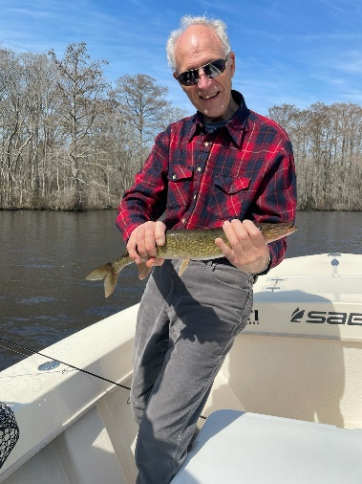
Rick Gorleski’s 20” pickerel on our first club trip.
Treasurer’s Report
We have (cttm) in our regular account and (cttm) in our scholarship fund account.
Board of Directors
We will be filling the vacancy left by the passing of Rob Feezer. One person has expressed interest in filling the position. If you have an interest, contact Tom Wilkison 410-404-3426.
Election of Officers
Our club officer’s terms expire at the end of this year. If you have an interest at serving as club president, vice president, recordingsecretary (webmaster) and/or treasurer please let Tom Wilkison (410-404-3426 ) know so your name can be placed in consideration for our fall election.
Reef Balls
The reef balls are poured. Buddy Connors and I will go to the concrete plant one day this week. We’ll strip and reform. We’re starting to get a nice number of reefballs in our cache and will soon start making arrangement to get them deployed.
Tournament Fishing
If you hear of a tournament that may be of interest to our members, let me know and I’ll spread the word via email.
Guest Speakers
We have no guest speaker this month as a lot of time will be spent on our Flounder tournament. Master Decoy carver, Warren Saunders has agreed to speak to us in the near future
Year Long Fishing Contest
We’ve got a couple more entries. A nice crappie from Guy Edgar IV, a nice pickerel from Tom Wilkison and a good sized catfish entered by Guy. Here’s a yellow perch Don Rollyson caught. A 10 incher. A lot have been caught, but this was the only one entered. Remember, this contest is only open to MSFC members in good standing. Here is our list to date:
Rock Fish 47 ¾” Chris Powel
Crappie 15” Guy Edgar IV
Catfish 44” Guy Edgar IV
Chain Pickerel 23 ¾” Tom Wilkison
Yellow Perch 10” Don Rollyson
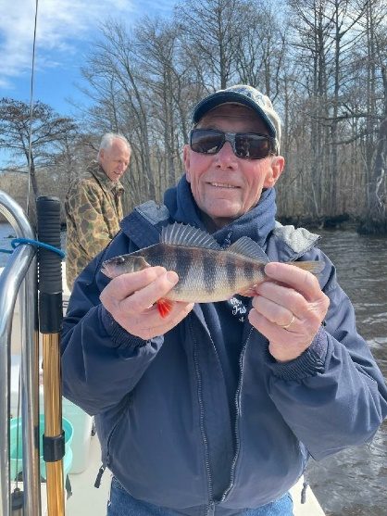

Dues
Folks, dues are due at the beginning of the year. I have attached the form, just fill it out and send your dues in. Its easy, all you have to do is do it.

Up Coming Events
MSFC monthly meeting March 18th Elks Club 7:00 pm
Luncheon April 1st noon Riverview at the Point
.Wachapreague Flounder Tournament April 9th and 10th More to come on this
Mid-Shore Fishing Club Flea Market… April 17th
Kid’s Fishing Derby… shooting for 1st week in August.

Scholarship
The University of Maryland has awarded this year’s Clint Water’s Memorial Scholarship to Alexandra McCarty. Hopefully we get to meet her soon.
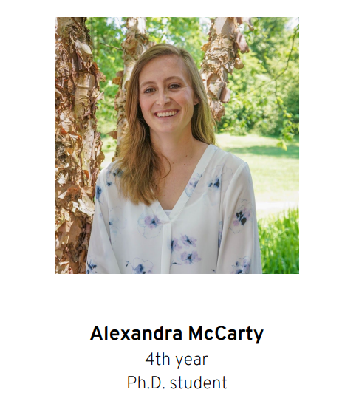

Flea Market
Our flea market is scheduled for April 17th. Because of covid restriction uncertainties, we may have it out side. We’ll make that call (in or out ) a little later. If we decide to have it outside we’ll use April 24th as a rain date.

Sponsors and Patrons
Folks, thank you for your support. We hope you continue this year. There is a place to do so on our membership application which is attached to the email that delivered this newsletter.

Patrons
 | 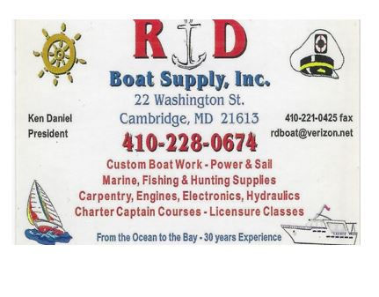
 | 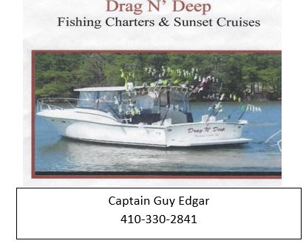 | 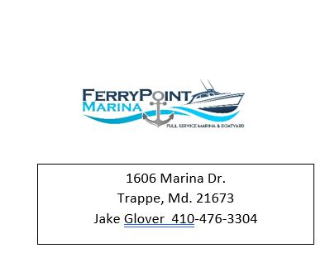

New Patron
Check out HSWT’s website for some great photos

Sponsors

Windy’s Upholstry  Mark Windmiller  219 Linthicum Ave.  Cambridge, Md. 21613  410-330-3056 | Tom & Debbie Cohee  Easton, Md. | J&L Services  (Jim & Hazel Burt )  General Contractor  Galestown Md 21659  410-943-3355
Robert Higgins
Trappe, Maryland
Little Humor

0000000000000000000000

