-June 14, 2021
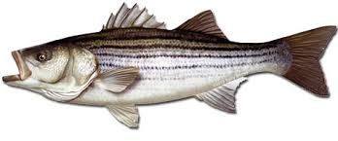
Mid-Shore Fishing Club

President – Tom Wilkison Reefball Coordinator – Bud Connors Vice President – Steve Schneider Scholarship Foundation – Steve Schneider Treasurer – Christy Helgason Raffles Committee –Don Rollyson
Webmaster – Bob Lawrence Club Fishing Tournaments Committee
Membership Committee –vacant – Chuck Prahl Christy Helgason Helmar Helgason
Guest Speakers –need someone to step up
Club Fishing Trips – vacant (looking for volunteer)
Flea Market – Harry Miller Tom Wilkison
Board Members- Tom Wilkison, Steve Schneider, Christy Helgason, Bob Lawrence, Harry Miller (n/v),
Steve Spellman, Rob Hardy, Bud Connors

NEXT MEETING June 17, 2021 7:00 PM at Elks Lodge #1272 Cambridge, Md. 21613

The Mid-Shore Fishing Club is dedicated to protect and preserve the rights and traditions of the recreational fisherman
May Meeting
May’s meeting was called to order at 7:00 pm. There were 16 members in attendance. Joe Opalski and Gary Peek won the 50/50.

Fishing Report
Plenty of small rock around the Choptank. Lots of small ( 1 ½” ) alewives around. Most keeper rock have been in shallow water at day break and later in the evening. Casting surface lures in the morning has been effective. Cooke’s Point has been better than Todd Point. Toby Frey has caught fish in Castle Haven and at Howell’s Point. There are reports of catching spec on bait as well as black drum on the Honga. Chuck Prahl picked up a 22” spec near Howell’s Point and more than a few keeper rock up to 24”. He was using a jighead with a paddle tail. Generally white with a yellow to chartreus paddle . The trolling trip out of Oxford became a live lining trip out of Kent Island. Our guys limited out aboard the Marianne.
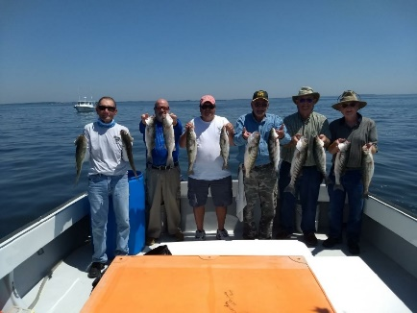
Live Lining aboard the Marianne

Club Trips
June 25 live lining for rock out of Kent Island closed
August 23rd and September 6th Cobia trips…folks will sign up (call Tom) and 6 names with be drawn from sign up list…subsidized
Augusts trips (2nd & 9th ) with Kevin Josenhans 3 anglers @ trip out of Crisfield July drawing winners eligible 1 trip only…subsidized
October trips (2nd & 16th) with Kevin Josenhans 3 anglers @ trip out of (choice) September drawing winners eligible 1 trip only..subsidized
Treasurer’s Report
We have (cttm) in our regular account and (cttm) in our scholarship fund account.
Election of Officers
Our club officer’s terms expire at the end of this year. If you have an interest at serving as club president, vice president, recordingsecretary (webmaster) and/or treasurer please let Tom Wilkison (410-404-3426 ) know so your name can be placed in consideration for our fall election.
Reef Balls
We have 40 reef balls ready to deploy and 4 in molds that need to be stripped. If they are successful we’ll have 44 ready to go. There are ongoing conversations about getting these reef balls deployed. More to come on this.
Tournament Fishing
If you hear of a tournament that may be of interest to our members, let me know and I’ll spread the word via email.

Guest Speakers
May’s guess speaker was Keith Lockwood. Keith prepare the fishing reports for Md. DNR. By all accounts Keith’s presentation was top notch. Keith lives on the Tuckahoe near the Choptank. He’s been with the DNR for over 30 years. Where he used to witness 3 or 4 striped bass spawning events, this past spring he saw one. There is still talk of further regulations regarding striped bass. Keith talked about watching large stripers head butting the cows, trying to facilitate an egg release. He’s seen the water white with milt. Pretty cool stuff.
June’s speakers are Bill Obrien and Joe Capp from Shore Tackle and Custom Rods
If you have any ideas for a speaker or a topic, please let us know. If there is a speaker you would like to hear, please let us know (with that speakers contact info). Respond to this email with your wishes
Year Long Fishing Contest

Rock Fish 49” Guy Edgar IV
Crappie 15” Guy Edgar IV
Catfish 44” Guy Edgar IV
Chain Pickerel 23 ¾” Tom Wilkison
White Perch 13 ¼” Guy Edgar IV
Largemouth 19 ½” Guy Edgar IV
Hickory Shad 17” Chuck Prahl
Brown trout 13” Joe Opalski
Flounder 22 5/8” Hilmar Helgason
Yellow Perch 11 ½” Joe Opalski
Blue gill 8 5/8” Steve Spellman
Speckled trout 20 ½” Guy Edgar IV

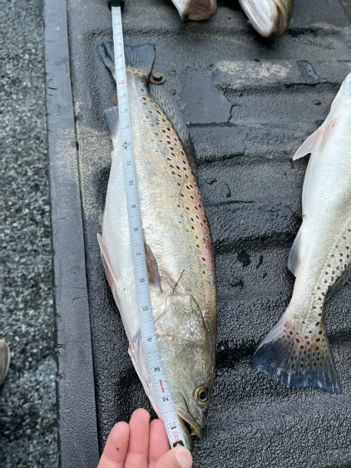
Guy’s 20 ½”er

Dues
Folks, dues are due at the beginning of the year. I have attached the form, just fill it out and send your dues in. Its easy, all you have to do is do it.
Up Coming Events
MSFC monthly meeting June 17th Elks Club 7:00 pm
Luncheon July 1st. noon Riverview at the Point
Kid’s Fishing Derby August 7th Long Wharf Park
see club trips above

Sponsors and Patrons
Folks, thank you for your support. We hope you continue this year. There is a place to do so on our membership application which is attached to the email that delivered this newsletter.

Patrons
 | 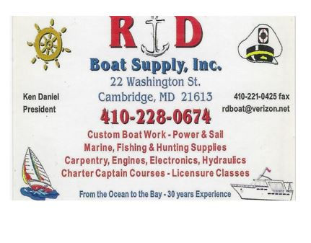
 | 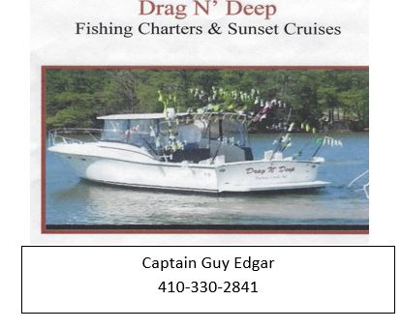 | 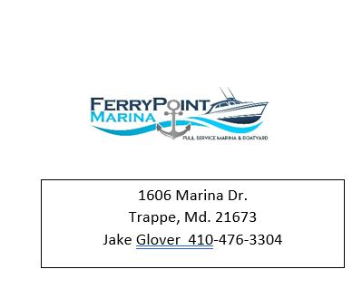

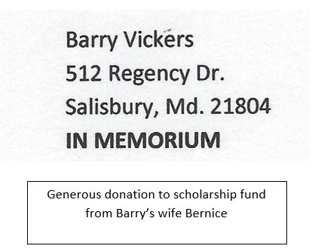

Sponsors

Windy’s Upholstry  Mark Windmiller  219 Linthicum Ave.  Cambridge, Md. 21613  410-330-3056 | Tom & Debbie Cohee  Easton, Md. | J&L Services  (Jim & Hazel Burt )  General Contractor  Galestown Md 21659  410-943-3355
Robert Higgins
Trappe, Maryland

We welcome a new sponsor Bert Olmstead from Grasonville and the Kent Island Fishing Club
Mobile Butcher Shop, LLC
Deer, Steer, & Hog Processing
Fish Filleting
Bert Olmstead
443-362-2235
boatman5@ymail.com

Little Fishing Humor

