January 17, 2021
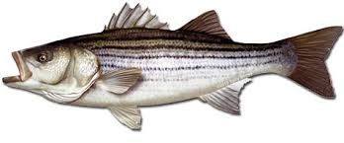
Mid-Shore Fishing Club

President – Tom Wilkison Reefball Coordinator – Bud Connors Vice President – Steve Schneider Scholarship Foundation – Steve Schneider Treasurer – Christy Helgason Raffles Committee –Don Rollyson
Webmaster – Bob Lawrence Club Fishing Tournaments Committee
Membership Committee –vacant – Chuck Prahl Christy Helgason Helmar Helgason
Guest Speakers – vacant Club Fishing Trips – vacant (looking for volunteer)
Flea Market – Harry Miller Tom Wilkison
Board Members- Tom Wilkison, Steve Schneider, Christy Helgason, Bob Lawrence, Harry Miller (n/v), Rob Feezer,
Steve Spellman, Rob Hardy

NEXT MEETING January 21, 2021 7:00 PM at Elks Lodge #1272 Cambridge, Md. 21613

The Mid-Shore Fishing Club is dedicated to protect and preserve the rights and traditions of the recreational fisherman
__________________________________________________________________________________________________

Our December 17th meeting was called to order. There we 16 attendees.
Fishing Report
FishTalk Magazine: Lenny talks about the yellow perch bite up north. Chuck and Tom went to Snow Hill and picked up one yellow perch on the Pocomoke fishing off the bank. Other than that, I have heard much. The taug fishing off OC is beginning.
Flea Market
Folks, our flea market is April 17th. If you are interested in a table ($30) contact Tom Wilkison 410-404-3426. Also, start thinking about your extra tackle or unwanted stuff (no junk) that you can donate to the club and we’ll sell at our Club Table.
Club Trips
We had 7 subsidized trips this year… a lot of good fishing. We hope to do more this coming year. Keep in mind you have to be a member in good standing to be eligible. By subsidized I mean the club picks up a large portion of the cost for the trip.

Treasurer’s Report
Our accounts are in good shape. Come to the meeting (CTTM) to get an accurate and up to date report.

Reef Balls
Bud and I went to the concrete plant last Thursday, stripped and reformed 4 reef balls. All four came out just fine. Now that Chaney only uses pea gravel as their aggregate, the results have been good. We now have 33 reef balls ready to deploy
50/50 Winners
John Bryde and Steve Spellman were last month’s winners
Tournament Fishing
If you hear of a tournament that may be of interest to our members, let me know and I’ll spread the word via email.
Year Long Fishing Contest

Here are our 2020 entries. These are the largest (by length) fish harvested in each species. Some pretty nice fish. All entries will be placed in a hat, and winners will be drawn at this month’s meeting. First place, $300…second place, $200…third place, $100. Good luck to all.
White Perch 12 ¼” Chris Powell
Yellow Perch 12 ½” Steve Spellman
Sea Bass 23 ¾” Chris Powell
Snakehead 34” Chris Powell
Channel Cat 26 ½” Josh Soper
Crappie 14 “ Guy Edgar IV
Blue Gill 8 ½” Steve Schneider
Large Mouth 19 ½ “ Don Rollyson
Rockfish 47” Guy Edgar IV
Black Drum 42” Neal D’Adamo
Speckled Trout 23 7/8” Tobey Frey
Cobia 56 1/2”” Chris Powell
Red Drum 47” Chris Powell
Flounder 23” Chris Powell
Ribbon fish 42” Guy Edgar IV
Spanish Mackerel 23 ½” Bobby Shenton
Blue fish 22 ½” Neal D’Adamo
Sheepshead 14.1 lb. Daniel Mastronardi Jr.
Kingfish 13 1/8” Bobby Shenton
Pompano 7 ¾” Steve Spellman
Lizardfish 14 ¼” Bobby Shenton
Hickory Shad 21” Rick Gorleski

Photos of all fish are available on our website www.mid-shorefishingclub.com look in photo gallery
Our 2021 Year Long Contest is underway. Have fun with it. Remember, this contest is only open to MSFC members in good standing. Entering the Clint Water Memorial Tournament does not pay your dues.
Dues
Folks, dues are due at the beginning of the year. I have attached the form, just fill it out and send your dues in. Its easy, all you have to do is do it.
Scholarship Fund
The Snakehead Raffle benefits our scholarship fund. Soon we’ll have a report as to how we did. Some time in the near future the University of Maryland will select our 2021 Clint Waters Memorial Scholarship recipient. Certainly, we’ll let you know who that is when it happens. We’ll try to arrange a time when all of us can meet our newest recipient
Guest Speakers
December’s speaker was Brett Dean of Rock the Choptank and Farmers insurance. Rock the Choptank organizers, Chris Powell and Brett presented us with a check for $570 from our Calcutta. These procedes are dedicated to our scholarship fund.
This month’s speaker is Greg Foxwell from Mid-Shore Electonics. Greg’s presentation will be more than helpful to all who have a boat with a chart plotter and a fishfinder. He will talk about the latest and greatest, the newest products out there on the market. He’ll discuss side scan and down scan and when to use them. He’ll address correct transducer placement. He’ll give us a chance to be better fishermen/fisherwomen.
Up Coming Events
January 21st meeting at the Elks Club
February 4th Luncheon at Riverview at the Point
.Wachapreague Flounder Tournament April 9th and 10th More to come on this
Mid-Shore Fishing Club Flea Market… April 17th
Kid’s Fishing Derby… shooting for 1st week in August.
Flea Market
Our flea market is scheduled for April 17th. Because of covid restriction uncertainties, we may have it out side. We’ll make that call (in or out ) a little later. If we decide to have it outside we’ll use April 24th as a rain date.
2020 Year in Review (briefly)
January, we were introduced to the podcast, “Blackwater’s Edge” with Eddie Bramble (Woolford Store) and Cas Kenny. We had our election of officers. Our guest speaker was our scholarship recipient, Jessie Long of Chrisfield. Steve Schneider won first and third in our Year Long contest and Chris Powell finished second.
February, we got our flea market in. We were lucky as other fishing clubs did not, as Covid-19 descended upon us. It was a success with all available tables sold and a larger crowd than 2019. Our guest speaker was CL Marshall of Pocomoke.
March, we had a board meeting before and the general consensus was we should have more subsidized fishing trips. We did not have a speaker (covid). There was a lot of planning for our “Good Ole Boys” flounder tournament next month. There was a subsidized trip to the Pocomoke for crappie, yellow perch and pickerel.
April, we had no meeting. We canceled our flounder tournament. Rock fishing was heavily curtailed as there was no “catch and release” and no trolling allowed. Chuck Prahl turned 90 (12th) . He is doing a fishing report on WHCP 101.5.
May, no meeting, no newsletter. May 6th we had a club trophy striped bass trip with Guy Edgar on the Drag-n-Deep. On the 29th we had a subsidized sea bass trip aboard the Angler out of OC. Good trip as most folks limited out.
June, no meeting, no newsletter.
July, guest speaker Bob Baker, knows more about flounder fishing than anyone I know.

August, Our Kid’s Fishing Derby was cancelled (covid). There was a striped bass closure from the 15th thru the 31st. Frank Whirley won the tuna division at this year’s White Marlin Open in OC with a 121 pounder. Daniel Mastronardi set a new state record for Sheepshead.
September, no speaker, prep for Clint Waters Memorial Tournament, held the 26th. Another huge success. Dave Smith, former MSSA executive was sentenced to 18 months and ordered to pay $136,000 restitution. We had three subsidized cobia trips aboard KingFisher II out of Deal Island.
October, Rock the Choptank was held the 24th. Another well run event.
November, Toby Frey was our guest speaker. There was a subsidized rock fishing trip with Guy Edgar aboard “Drag-n-deep”.
December, Our Christmas dinner was postponed. Our guest speaker was Brett Dean.
Chapter Eternal
We lost long time members Bill Walker and Ed Ream this past year. Our thoughts and prayers go out to their families. If I have failed to mention anyone who has passed, please forgive me.
Sponsors and Patrons
Folks, thank you for your support. We hope you continue this year. There is a place to do so on our membership application which is attached to the email that delivered this newsletter.

Sponsors
Island Tackle  1915 Main St.  Chester MD 21619  410-643-4099 | Joe Camp  5613 Riverton Rd.  Cambridge, MD 21613 | Tom & Debbie Cohee  Easton, MD
Windy Upholstery & Canvas  Cambridge, Md. 21613  Mark Windmiller  410-221-0981 | J&L Services  (Jim & Hazel Burt )  General Contractor  Galestown Md 21659  410-943-3355 | Barry Vickers (In memorium)  512 Regency Dr  Salisbury Md.
Patrons

Composite Yacht  1650 Marina Dr. Unit A  Trappe, MD 21673  Martin Hardy  cell 443-521-4422  office 410-476-4414 | Mid-Shore Electronics  205 Trenton St.  Cambridge, Md. 21613  410-228-7335  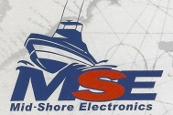 | Blue Water Marine  5469 Moose Lodge Rd  Cambridge, Md. 21613  410-228-0000
R&D Boat Supply  22 Washington St.  Cambridge, MD 21613  410-228-0674  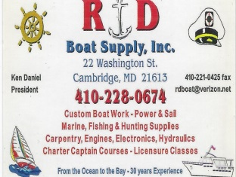 | Woolford Store  1615 Taylor Island Rd.  Woolford, MD 21677  Edwin Bramble  443-521-4680 | Ferry Point Marina  1606 Marina Dr.  Trappe, MD 21613  Jake Glover  410-476-3304  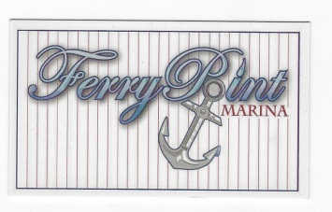
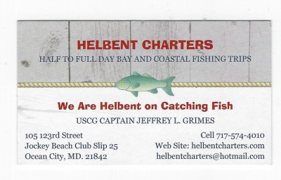 | Chris Cianci  410-820-4070 | Ed Cartwright  484-280-7842
EPRI Edgemont Precision Rebuilders, Inc.  Steve Smith  1758 Travers Wharf Rd. Bldg. B  Cambridge, Md. 21613 | Edsall Turf Management  12519 Wetland View Ct.  Cordova, MD 21625 | 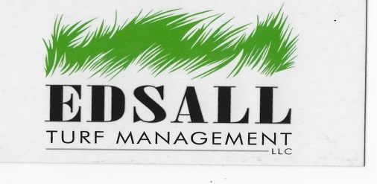

Humor
Out of the humor/wisdom selections this past year, this receive the most feedback. Here it is again.
I have to left double click it and then click open.

