April 10, 2021
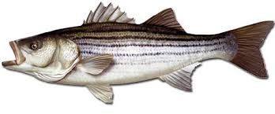
Mid-Shore Fishing Club

President – Tom Wilkison Reefball Coordinator – Bud Connors Vice President – Steve Schneider Scholarship Foundation – Steve Schneider Treasurer – Christy Helgason Raffles Committee –Don Rollyson
Webmaster – Bob Lawrence Club Fishing Tournaments Committee
Membership Committee –vacant – Chuck Prahl Christy Helgason Helmar Helgason
Guest Speakers – vacant Club Fishing Trips – vacant (looking for volunteer)
Flea Market – Harry Miller Tom Wilkison
Board Members- Tom Wilkison, Steve Schneider, Christy Helgason, Bob Lawrence, Harry Miller (n/v),
Steve Spellman, Rob Hardy

NEXT MEETING April 15, 2021 7:00 PM at Elks Lodge #1272 Cambridge, Md. 21613

The Mid-Shore Fishing Club is dedicated to protect and preserve the rights and traditions of the recreational fisherman
__________________________________________________________________________________________________
March Meeting
March’s meeting was called to order at 7:00. There were 27 attendees. There was a moment of silence for our departed brother Rob Feezer. Tom W. talked about the importance of attending meetings as our club subsidized trip anglers are selected from our attendance bucket. Don Rollyson spoke of his trip on the Pocomoke with Kevin Josenhans. A little windy, but a great trip. A lot of yellow perch and crappie were caught as well as a few chain pickerel.

Fishing Report
Keep in mind, targeting of rockfish is off limits until May 1st. The white perch spawn run is still on, but beginning to ebb. Grass shrimp and bloodworms are effective baits. Bobby Shenton and Terry Tubman picked up a nice batch on the Nanticoke near Sharptown
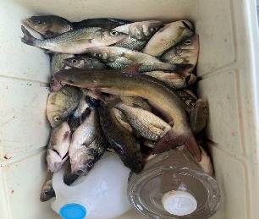
Some yellow perch are still being caught below their spawning grounds. Folks are picking up hickory shad at Newbridge with either shad darts or small jigheads with very soft white Mr. Twisters. Chuck Prahl picked up a 17 7/8” incher using the jighead on a tandem rig with split shot on the shorter leader.
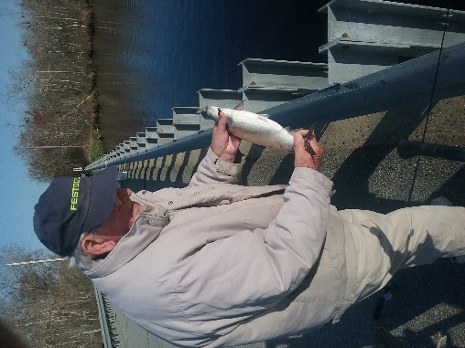
Pond fishing has been good. Guy Edgar IV picked up a 5 lb. 19 ½” largemouth.
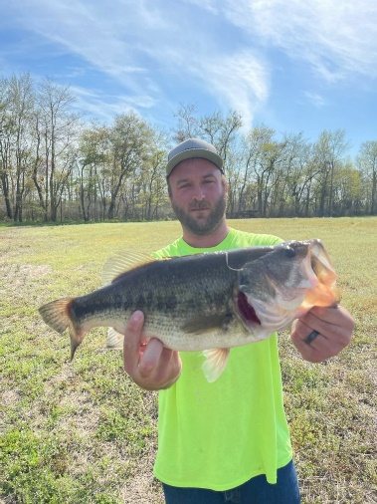

Flea Market
Folks, our flea market is this coming Saturday, April 17th. We are having it inside the Elks Club. If you are interested in a table ($30) contact Tom Wilkison 410-404-3426. Also, get your extra tackle or unwanted stuff (no junk) that you can donate to the club and we’ll sell at our Club Table. It’s a good fund raiser for us. Tom and Bob put up additional signage (with permission from the City…thanks to those folks) along Route 50 advertising the date. Doors will open at 8:00 am. We’ll need help Friday night setting up. We’ll begin that operation at 3:00 PM when the Elks Club opens
Tell you friends and neighbors. Hopefully we’ll have a great turnout.

Club Trips
We drew names out of the attendance bucket for a Spring Trophy trip with Guy Edgar aboard the “Drag N Deep”. The winners were Bob Strakes, Bob Granados, Harry Miller, Bob Geisler, and Rick Gorleski. Our backups are Tanya Harding, Chris Powell, and Josh Soper, in that order. They’ll leave out of Ragged Point and you all should have each others contact info. This trip is scheduled for May 3rd.
Treasurer’s Report
We have (cttm) in our regular account and (cttm) in our scholarship fund account.
Board of Directors
Our Board of Directors vacancy has been filled. Albert (Bud) Connors was unanimously elected to fill the position left by the departure of Rob Feezer
Election of Officers
Our club officer’s terms expire at the end of this year. If you have an interest at serving as club president, vice president, recordingsecretary (webmaster) and/or treasurer please let Tom Wilkison (410-404-3426 ) know so your name can be placed in consideration for our fall election.
Reef Balls
We have 37 reef balls ready to deploy. We don’t expect to have any more poured in the next few weeks as Chaney Enterprises will be making modificatiosn to their batch plant and won’t be operational for a bit. We are now considering Chaney as one of our patrons as they provide concrete material and manpower at no cost to us. They are a great asset to our reef ball effort. According to member Tobey Frey, CCA is applying for a permission to create a reef near the Long Wharf Light House. We’ll try to become a part of that effort. When each reef ball is poured with concrete there is some over pour. That is the nature of the beast. I spoke with Tom that we need a electric chipping gun to facilitate form removal. He agreed and we are asking Bud Connors ( our Reef Ball coordinator) to search and purchase one.

Tournament Fishing
If you hear of a tournament that may be of interest to our members, let me know and I’ll spread the word via email.
Guest Speakers
This month’s is Chris from Big Bass Kayaks Chris will talk to us about the various kayak models and their uses. Should be very interesting to all outdoors folks and skinny water (snakehead) fishermen.
Year Long Fishing Contest
We’ve got a few more entrieRemember, this contest is only open to MSFC members in good standing. Here is our list to date:
Rock Fish 47 ¾” Chris Powel
Crappie 15” Guy Edgar IV
Catfish 44” Guy Edgar IV
Chain Pickerel 23 ¾” Tom Wilkison
Yellow Perch 10” Don Rollyson
Largemouth 19 12” Guy Edgar IV
Hickory Shad 17 7/8” Chuck Prahl
Flounder 22 5/16” Hilmar Helgason

Dues
Folks, dues are due at the beginning of the year. I have attached the form, just fill it out and send your dues in. Its easy, all you have to do is do it.

Up Coming Events
MSFC monthly meeting April 15th Elks Club 7:00 pm
Luncheon May 6th noon Riverview at the Point
Mid-Shore Fishing Club Flea Market… April 17th
Kid’s Fishing Derby August 7th Long Wharf Park
Scholarship
The University of Maryland has awarded this year’s Clint Water’s Memorial Scholarship to Alexandra McCarty. 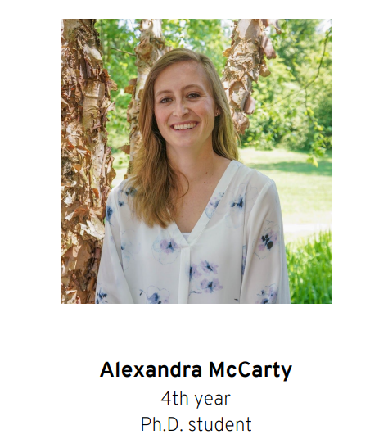Hopefully we get to meet her soon.
More Flea Market
Our flea market is this Saturday, April 17th. We are having it inside the Elks Club. Doors will open at 8:00 am. We’ll need help Friday night setting up. We’ll begin that operation at 3:00 PM when the Elks Club opens
Good Ole Boys Flounder Tournament
The Good Ole Boys Flounder tournament was held this past Friday and Saturday in Wachapreague Va. Here’s the results I received from Christy. “Friday came with some winds, however Saturday was beautiful with lots of sun and light wind.
Friday Winners: 12 flounder checked in
1st-Richard English 21 ¼
2nd-JJ Harding 20 1/4
3rd-Robert Meilhammer 19 ¾
|Boat Calcutta went to Richard English and Carter Jarrell
50/50 Joey Harding $130.00
Saturday WInners: 17 Flounder checked in
1st-Hilmar Helgason 22 5/16
2nd-Hazel Burt 22
3rd-Carter Jarrell 21 3/8
Boat Calcutta went to Hilmar and Christy, Jim and Hazel Burt
50/50 Mike Trice 115.00
It was a fun weekend!!”

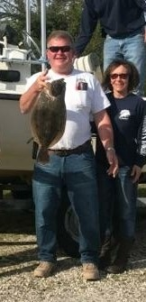 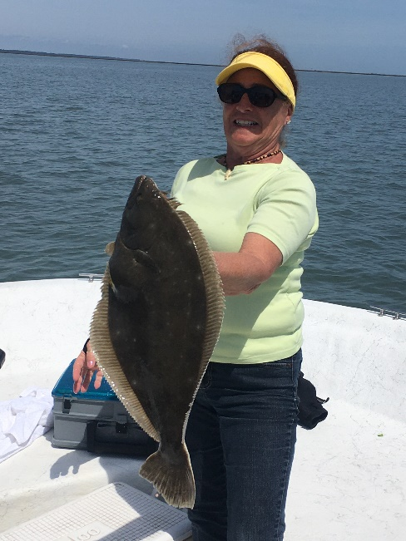
Hilmar 22 ½” Hazel Burt 22”
Sponsors and Patrons
Folks, thank you for your support. We hope you continue this year. There is a place to do so on our membership application which is attached to the email that delivered this newsletter.

Patrons
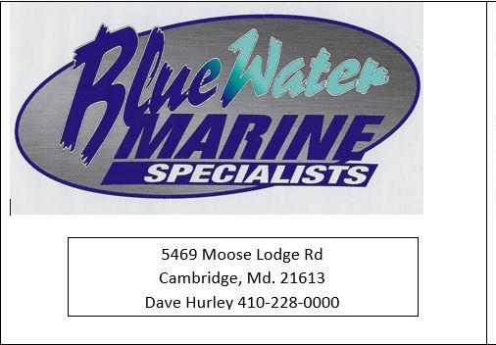 | 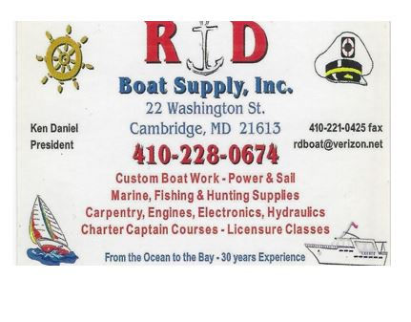
 | 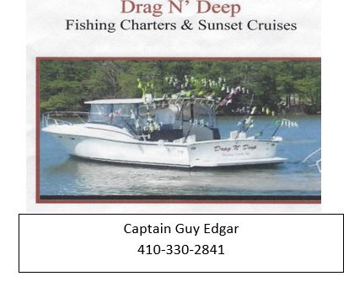 | 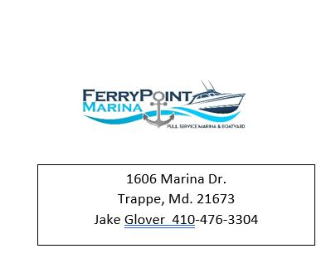

New Patron

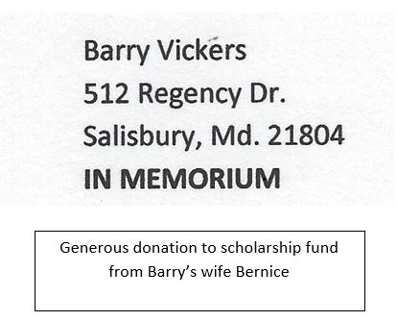

Sponsors

Windy’s Upholstry  Mark Windmiller  219 Linthicum Ave.  Cambridge, Md. 21613  410-330-3056 | Tom & Debbie Cohee  Easton, Md. | J&L Services  (Jim & Hazel Burt )  General Contractor  Galestown Md 21659  410-943-3355
Robert Higgins
Trappe, Maryland
Little Humor

