November 18 2019
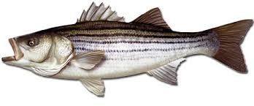
Mid-Shore Fishing Club

President – Harry Miller (Tom Wilkison president elect) Vice President – Steve Schneider
Legislative Committee – Bob Geisler Treasurer – Bob Granados
Christy Helgason (elect)
Membership Committee –vacant Club Fishing Tournaments Committee – Chuck Prahl Christy Helgason Helmar Helgason
Guest Speakers – vacant Club Fishing Trips – vacant (looking for volunteer)
Webmaster – Bob Lawrence Flea Market – Harry Miller Tom Wilkison
Scholarship Foundation – Steve Schneider Raffles Committee –Don Rollyson
Reefball Coordinator – Tom Wilkison (Bud Connors coordinator elect)

NEXT MEETING November 21 , 2019 7:00 PM at Elks Lodge #1272 Cambridge, Md. 21613

The Mid-Shore Fishing Club is dedicated to protect and preserve the rights and traditions of the recreational fisherman
The October 17th meeting was called to order at 7:00. There were 14 attendees
Treasurers’ Report
There was not a formal Treasurer’s report, but President Harry Miller reported we had $CTTM in our account. We have $1755 in our scholarship fund and the membership voted to add $1500 to that account.
Presidents Report
Our Christmas Partly will be Saturday, December 7th at Johnny’s Tavern, 1:00 to 4:00. A cost of $15 will provide a prime rib dinner with a crab cake to boot. You can bring you money ($15 did you hear that) to the meeting or find a way to get your payment to Harry Miller email or text (hamjr2000@gmail.com) (301-807-4267) or to Bobby Granados 410-251-7518
Our Flea Market will be February 29th, the same day as the National Outdoor Show in Golden Hill. Tom Wilkison will be the prime mover on this event. Start thinking about donations to our club table, stuff you don’t use or want to get rid of.
Get you tickets in for the raffle for the flounder trip on the Helbent with Captain Jeff Grimes. If you have tickets to get in, I don’t think you have time to mail them, so make arrangements to get them to the meeting. The drawing is this coming Thursday the 21st.
We are going to develop another raffle for a snakehead trip. More to come on this.

Reefballs
A bunch of us went to the concrete plant last month and stripped and reformed 4 reefballs. This particular batch was somewhat better than previous pours. We made some alterations to the forms, talked with the plant foreman. We left some tools, all in an attempt to make it easy for Chaney Ent. to create quality reefballs

Year Long Fishing Contest
Time is getting short for this season. Let hope fall brings lots of action. Here are our entries to date. There are a couple of New entries. Get you entries and photos in. Deadline is December 31st 2019 at midnight. There are photos of all entries on our website www.mid-shorefishingclub (copy and paste link to your browser) click Photo Gallery/Year Long Tournament 2019

Charlie Schneider 37” rock
Chuck Prahl smallmouth bass
Don Cochran 21” speckled trout
Steve Schneider 19” largemouth bass
Steve Schneider 17 ¾” pickerel
Bob Lawrence 16” hickory shad
Steve Schneider 13 ½” yellow perch
Steve Spellman 12 ½” crappie
Steve Schneider 10 ½” croaker
Steve Schneider 8 7/8” spot
Chris Powell 49” red drum
Barb Lawrence 26” peacock bass
Brian Smith 30” blue cat (no photo observed at meeting)
Joe Opalski 28” snakehead
Chris Powell 46 ½” cobia
Brian Smith 44” gar
Conrad Lesnewski 24” tautog
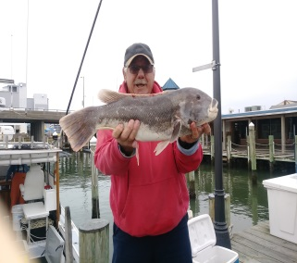 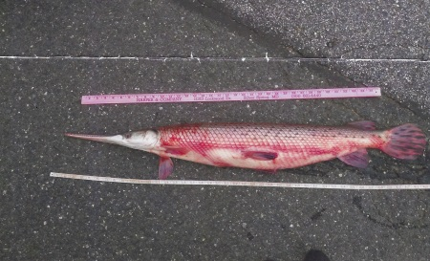
Conrad’s tog Brian’s gar

Club Fishing Trips
We are still looking for someone to step up and organize club trips. Club assets are growing so, a subsidized trip or two may become a possibility. Conrad Lesnewski has been fishing aboard a headboat, The Angler out of Ocean City and having success with seabass, trigger fish and tautog as the water has cooled. The cost has been $68 per trip. You’d have to contact the Angler to get details. Maybe we can get a club member to organize a trip for us.
Tournament Fishing
I will still try to compile a list of local tournaments. When you hear of them, please let me know and I’ll get the word out as quickly as possible. I can put them on the calendar of events .

Rock the Choptank
The Rock the Choptank was won again this year by club member Christy Helgason and the crew of Indian Outlaw.

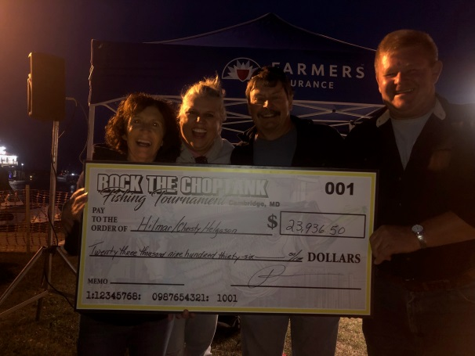
Guest Speakers
Last month we had no formal speaker, but President Harry Miller gave us a “where we were / where we are” presentation. We’ve come along way brothers and sisters.
This month’s speaker is Captain Doug Collison. Doug is a relief captain and first mate aboard the Backdraft. The Backdraft is a 46’ charter boat out of Deal Maryland.

Upcoming Events
November 21 meeting 7:00 at the Elks Club #1272
December 5th luncheon at 12:00 Katie Mae’s
December 7th Christmas Dinner at Johnny’s Tavern 39 Main St. East New Market, Md.

Elections of Officers
Your new officers, starting January 1st, 2020 are:
President Tom Wilkison
Vice President Steve Schneider
Treasurer Christy Helgason
Secretary Bob Lawrence
Board of Directors Rob Feezer
Steve Spellman

Kids Fishing Derby
Harry Miller did a KFD wrap up interview on WHCP 101.5. Here is a link to that interview
https://m.soundcloud.com/whcp-radio/sets/fishing-derby
listen in
Next years derby is scheduled for August 1st with August 8th as a rain date

ASMFC Hearing
The ASMFC hearing has come and passed, as has the period for comment. Sometime by the first of next year we should know the new (if any) stripped bass regulations. I’ll let you know as soon as we hear anything.
Clint Waters Memorial Fishing Tournament
The Clint Waters Memorial Fishing Tournament has come and gone. Another success. We had 40 boats, with 142 anglers and 102 folks participating in our Calcutta. There were new memberships and many renewals. Many thanks to the Helgason’s for their efforts and the use of their facilitly. There are many folks who contribute in many ways to the success of this outing, we thank all of you as well.

Scholarship
Our scholarship fund, thru a partnership with the University of Maryland awarded a $2500 grant to Jessie Todd Long, from Crisfield Maryland. You will get to meet Jessie at our January meeting. Here’s a photo of Jessie and Harry Miller at the award ceremony in College Park
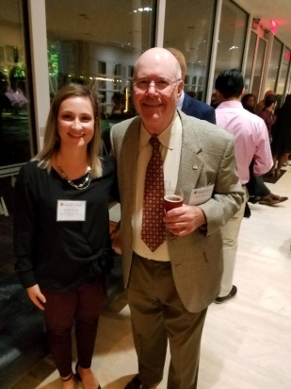
Here’s a copy of the thank you letter we received from Jessie

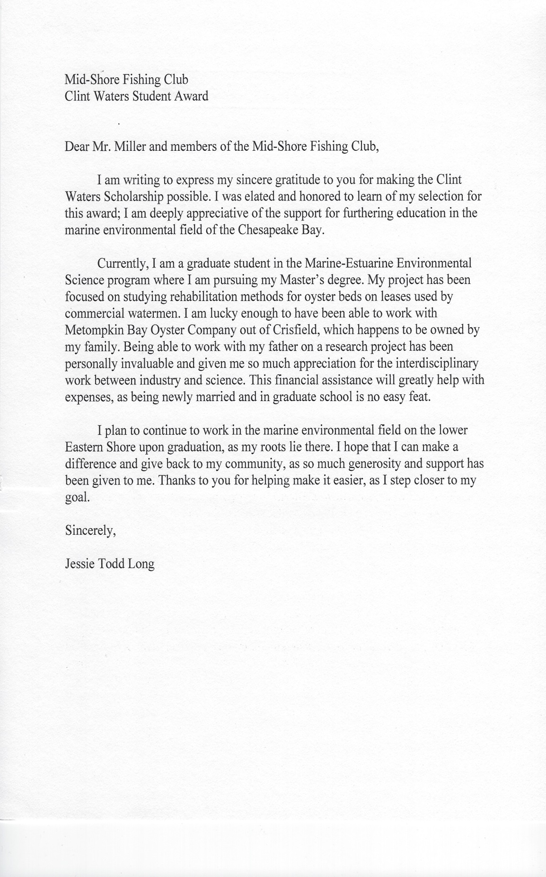

Sponsors and Patrons
We would love to get more Sponsors and Patrons to join our club. Remember that any individual or business can join. Businesses need not be associated with the marine or fishing industry. Any business can become a sponsor or a patron of our club. We all know people and businesses that we do business with that might have an interest in supporting our club. So the next time you talk with them see if they might do so.
The next pages are dedicated to our sponsor and Patrons who want us to succeed. Please support them.
Patronages and Sponsorships are a yearly endeavor and current participation will expire Dec. 31st. We hope current folks will re-up and more folks will join our efforts.

Sponsors

Island Tackle Outfitters Joe Camp Tom & Debbie Cohee
1915 Main st. 5613 Riverton Rd. Easton Md.
Chester, Md. 21619 Cambridge, Md. 21613
Dave Tolbert
410-643-4099
Windy Upholstery & Canvas
Cambridge, Md. 21613
Mark Windmiller
410-221-0981
Barry Vickers (In memorium) J&L Services
512 Regency Dr.
Salisbury Md. Seaford De. 19973

Patrons

Composit Yacht Mid-Shor Electonics BlueWater Marine
1650 Marina Dr. unit A 205 Trenton St. 5469 Moose Lodge Rd
Trappe, Md. 21673 Cambridge, Md. 21613 Cambridge, Md. 21613
Martin Hardy 410-228-7335 410-228-0000
c 443-521-4422
off 410-476-4414
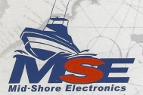
R&D Boat Supply Woolford Store Ferry Point Marina
22 Washington St. 1615 Taylor Island Rd. 1606 Marina Dr.
Cambridge, Md. 21613 Woolford, Md. 21677 Trappe, Md. 21673
410-228-0674 Edwin Bramble Jake Glover
443-521-4680 410-476-3304
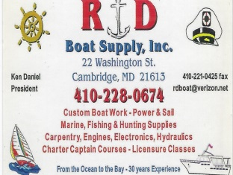 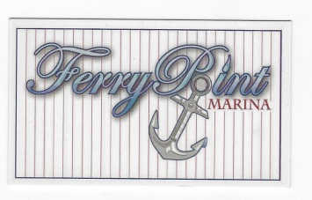

Chris Cianci Ed Cartwright
410-820-4070 484-280-7842

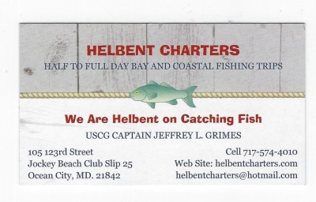

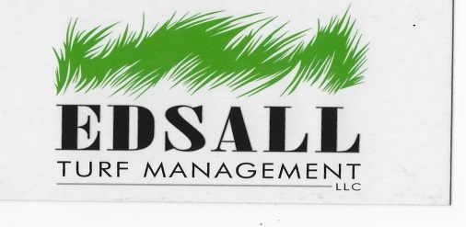
Edsall Turf Management
12519 Wetland View Ct.
Cordova Md. 21625

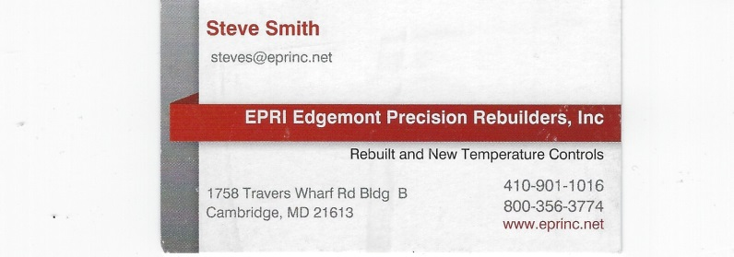
EPRI Edgemont Precision Rebuilders, Inc.
Steve Smith
1758 Travers Wharf Rd. Bldg. B
Cambridge, Md. 21613
A Little Fishing Humor
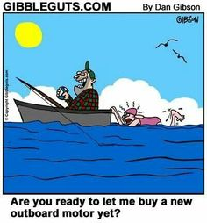
We still miss you Barry.

