July 9 , 2019
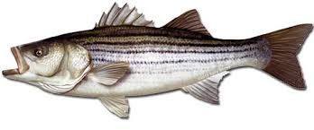
Mid-Shore Fishing Club

President – Harry Miller Vice President – Steve Schneider
Legislative Committee – Bob Geisler Treasurer – Bob Granados
Membership Committee – Frank Whirley Club Fishing Tournaments Committee – Chuck Prahl Christy Helgason Helmar Helgason
Guest Speakers – vacant Club Fishing Trips – vacant (looking for volunteer)
Webmaster – Bob Lawrence Flea Market – Harry Miller Tom Wilkison
Scholarship Foundation – Steve Schneider Raffles Committee –Don Rollyson
Reefball Coordinator – Tom Wilkison

NEXT MEETING July 18 , 2019 7:00 PM at Elks Lodge #1272 Cambridge, Md. 21613

The Mid-Shore Fishing Club is dedicated to protect and preserve the rights and traditions of the recreational fisherman
The June 20th meeting was called to order at 7:00. There were 17 attendees
Treasurers’ Report
The is $CTTM in our checking account.
Presidents Report
We are now a 501-C7 Social Club. We have a degree of tax freedom, but we are not a tax deductible organization.
Get you tickets in for the raffle for the flounder trip on the Helbent with Captain Jeff Grimes.
We are taking sweatshirt orders. We need 12 pieces to place an order:
Hoodies $35
Sweatshirt $35
Jacket with zipper $40
contact Harry Miller 301-807-4267
There was post meeting side chatter about getting hats made.

Scholarship
We have entered a partnership with the University of Maryland. We will provide $10,000 over the next five years and they administer and award a $2000 scholarship to an Eastern Shore resident who is studying some sort of marine/environmental science. You can contact Steve Schneider for more information 410-310-0574 or Stevejs1@verizon.net . We have met with the University of Maryland and signed the contracts.
Helbent Charters out of Ocean City, Md.(one of our newest patrons) is providing our scholarship fund with a flounder charter. We are selling raffle ticket at all meetings and events. The trip will be awarded next fall for the 2020 season. Tickets will be $3 each or 4 for $10. All procedes go to the scholarship fund.
REMINDER … the tickets folks have and are trying to sell for the scholarship fund, get them in to Harry.
Reefballs
We are waiting for the concrete plant to let us know if the next batch is ready to process.

Year Long Fishing Contest
Here are our entries to date. Get you entries and photos in.

Charlie Schneider 37” rock
Chuck Prahl smallmouth bass
Don Cochran 21” speckled trout
Steve Schneider 19” largemouth bass
Steve Schneider 17 ¾” pickerel
Bob Lawrence 16” hickory shad
Steve Schneider 13 ½” yellow perch
Steve Spellman 12 ½” crappie

Club Fishing Trips
We are still looking for someone to step up and organize club trips. Club assets are growing so, a subsidized trip or two may become a possibility.

Tournament Fishing
I will still try to compile a list of local tournaments. When you hear of them, please let me know and I’ll get the word out as quickly as possible. I can put them on the calendar of events
Guest Speakers
Last month’s speakers were Eddie Bramble of Woolford Country Store and Caz Kenny of snakehead fame. These guys gave an outstanding presentation regarding snakeheads. They cleared up some misconceptions. Caz has opened over a 1000 snakeheads to see what they are eating; pretty much everything…frogs, snakes, baby ducks, baby muskrats, and soft crabs. They are a ferocious predator in shallow waters. A snakehead will eat its weight in 4 days They are found in most all tributaries and well as the Susquehanna flats (for at least 3 years). They grow fast and can spawn up to 5 times a year. It is illegal to posses a live snakehead. Right now all we can do is catch as many as you can.

We are trying to get someone knowledgeable about vibrio to speak at July’s meeting. Nothing was confirmed at the time of this newsletter, but I think it will happen. Plan to attend

Upcoming Events
July 18th meeting at the Elks Club
August 3 Kid’s Fishing Derby
September Clint Waters Memorial Fishing Tournament
October “Rock the Choptank” fishing tournament
Kids Fishing Derby
Some folks have stepped up to keep the Kids Fishing Derby up and running. Steve Schneider is getting together flyers, and getting the information out to the community about date and time. Steve will be a prime organizer. He’ll put together spreadsheet for all the kids with their information. Harry Miller and Rob Feezer will be receiving calls and email for folks to register. Tom Wilkison will check out all our rod and reels and rigs, which should be ready to go. Steve, Harry, Rob and Tom will work together to make sure everything is cover. A lot will be discussed at the upcoming meeting, so if you can make it and find a way to lend a hand, that would be good. I am attaching a flyer to this email. Please print it out and put it up in you neighborhood.
Elections of Officers
The nominating committee is preparing a list of candidates for our October election. It will be presented to the membership at the September meeting. If you have any interest in being President, Vice President, Secretary or Treasurer, let members of the nominating committee know:
Chuck Prahl 443-521-4138
Tom Wilkison 410-404-3426
Rob Feezer 443-477-3634

Sponsors and Patrons
We would love to get more Sponsors and Patrons to join our club. Remember that any individual or business can join. Businesses need not be associated with the marine or fishing industry. Any business can become a sponsor or a patron of our club. We all know people and businesses that we do business with that might have an interest in supporting our club. So the next time you talk with them see if they might do so.
The next pages are dedicated to our sponsor and Patrons who want us to succeed. Please support them.
Patronages and Sponsorships are a yearly endeavor and current participation will expire Dec. 31st. We hope current folks will re-up and more folks will join our efforts.

Sponsors

Island Tackle Outfitters Joe Camp Tom & Debbie Cohee
1915 Main st. 5613 Riverton Rd. Easton Md.
Chester, Md. 21619 Cambridge, Md. 21613
Dave Tolbert
410-643-4099
Windy Upholstery & Canvas
Cambridge, Md. 21613
Mark Windmiller
410-221-0981

Barry Vickers (In memorium) J&L Services
512 Regency Dr. Seaford De. 19973
Salisbury, Md. 21613

Patrons

Composit Yacht Mid-Shor Electonics BlueWater Marine
1650 Marina Dr. unit A 205 Trenton St. 5469 Moose Lodge Rd
Trappe, Md. 21673 Cambridge, Md. 21613 Cambridge, Md. 21613
Martin Hardy 410-228-7335 410-228-0000
c 443-521-4422
off 410-476-4414
R&D Boat Supply Woolford Store Ferry Point Marina
22 Washington St. 1615 Taylor Island Rd. 1606 Marina Dr.
Cambridge, Md. 21613 Woolford, Md. 21677 Trappe, Md. 21673
410-228-0674 Edwin Bramble Jake Glover
443-521-4680 410-476-3304
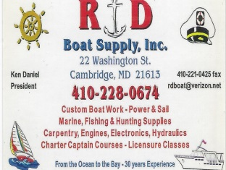 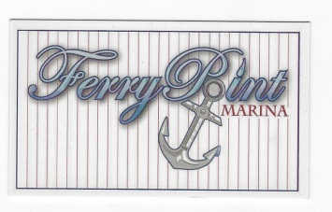

Chris Cianci Ed Cartwright
410-820-4070 484-280-7842

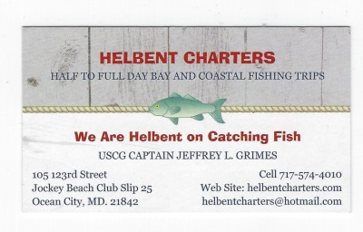

The Humor of Barry Vickers

1-I thought growing old would take longer..
2-I do not snore, I dream I’m a motorcycle
3-Pretty sure I’m going to be one of those senior citizens who bites everyone
4-people keep thinking that I care—Go figure
5-When I was a kid I wanted to be older—this crap is not what I expected
6-I would like to thank my middle finger for always sticking up for me when I needed it
7-I don’t need anger management—I need you to stop PISSING me off
8-Never underestimate an old man with a motorcycle
9-Wine improves with age—I improve with wine
10-I consider on time to be when I get there
11-I may be wrong but I doubt it
12-So when is this old enough to know better supposed to kick in
13-I can’t believe how old people my age are
14-nobody listens to me till I fart
15-money doesn’t buy happiness unless you spend it on wine
16-I meant to behave but there were too many other options
17-The best thing about the good ole days was that I wasn’t good and I wasn’t old

