October 12, 2020
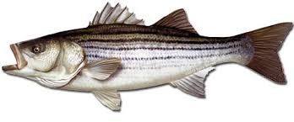
Mid-Shore Fishing Club

President – Tom Wilkison Reefball Coordinator – Bud Connors Vice President – Steve Schneider Scholarship Foundation – Steve Schneider Treasurer – Christy Helgason Raffles Committee –Don Rollyson
Webmaster – Bob Lawrence Club Fishing Tournaments Committee
Membership Committee –vacant – Chuck Prahl Christy Helgason Helmar Helgason
Guest Speakers – vacant Club Fishing Trips – vacant (looking for volunteer)
Flea Market – Harry Miller Tom Wilkison
Board Members- Tom Wilkison, Steve Schneider, Christy Helgason, Bob Lawrence, Harry Miller (n/v), Rob Feezer,
Steve Spellman, Rob Harding

NEXT MEETING October 15, 2020 7:00 PM at Elks Lodge #1272 Cambridge, Md. 21613

The Mid-Shore Fishing Club is dedicated to protect and preserve the rights and traditions of the recreational fisherman
__________________________________________________________________________________________________
Dues…for those members who didn’t purchase dues for three years and/or whose dues expire 12/31/2019, its past time to update your membership. Dues are $15/year individual, $20/year/ family, $40/3 years /individual, and $55/3 years/ family. You can bring your payment to the meeting or you can mail a check (made out to Mid-Shore Fishing Club) to :
Mid-Shore Fishing Club
PO Box 514
Cambridge, Md. 21613
Keep in mind, our fiscal year is January 1st through December 31st. If your dues are paid up you are eligible for our club subsidized fishing trips. We had 4 this year so far, 1 seabass trip and 3 cobia trips. We will have more next year. We want to get a couple of rockfish trips in like we used to. If dues are up to date you can participate in our “Year Long Contest”, your are eligible for our Christmas dinner, which the club picks up a large part of the tab. Your dues help support our “Kid’s Fishing Derby” and our Scholarship fund. We make an effort to get some really good speakers and folks have been really goods at that. We build reefballs for deployment in Marland waters and dues help to support that effort. Folks, $15 ain’t squat for all that and more. Plus you get this really quality monthly newsletter. It sure makes it easier on all of us if you pay your dues at the beginning of the year and try to stay up to date.

Our September 17th meeting was called to order. There we 25 attendees

Fishing Report ( at September meeting)
At the time of our September meeting Specs and a few keeper rock were being taken near Howell Point. Reports were, “there were a lot of fish in the river”. Folks have been picking up a lot of +10” perch upriver in the Choptank and in the Little Choptank as well
More Fishing News
Rock have breaking in the early evening from Sandy Hill towards 16. Buddy C. has picked up fish in both places. Folks are casting, jigging and trolling around 13 and 12A
Treasurer’s Report
Our accounts are in good shape. Come to the meeting (CTTM) to get an accurate and up to date report, especially after the Clint Waters Memorial Tournament.
Board Members
Rob Feezer, Rob Harding and Steve Spellman have agreed to continue as board members
Reef Balls
Last week we stripped two forms that had been poured, bringing our total to 24. We got all 4 ready to pour. Bud C. stopped by Friday , and Chaney had poured them all. Shortly we will organize a work party to strip and reform those. Some of our inflatable are at least 8 years old and have failed. We purchased 3 of the 15” center ones so we should be good to go for a while. We’ll put out a request for help when we get a date for the work party.
50/50 Winners
Chuck Prahl Bobby Granados
Clint Waters Memorial Fishing Tournament
This year event has come and gone and by All accounts it was a success. There were----- boats and -----anglers participating. The list with the lengths of the winning fish were miss placed, but here are your winners:
Rockfish White Perch Catfish Snakehead Mystery Fish
Scott Sockriter Guy Edgar IV JJ Harding Guy Edgar IV Steve Schneider
Shelby Ruf Guy Edgar III Andrew Arnold Guy Edgar III (speckled trout)
Sandy Dorman Lee Neild Josh Soper
Glenn Brown Brad Cannon Jason Maggio
Steve Schneider Josh Soper Rhonda Barnhart
Rock the Choptank Calcutta JJ Harding
Funk Audio and Marine Electronics Calcutta Josh Soper
There are a lot of folks and businesses that have contributed to the success of this tournament. They will be addressed if a future email. We’d like to pass a special thanks to Brad Cannon who donated his white perch winnings to the club and to Leifur Helgason who donated his 50/50 winnings back to the club as well.
Rock the Choptank
Saturday October 24th
You can go to Rock the Choptank’s facebook page to get more information and to register
https://www.facebook.com/RockTheChoptank/

Tournament Fishing
If you hear of a tournament that may be of interest to our members, let me know and I’ll spread the word via email.
Year Long Fishing Contest

Here are our 2020 entries to date:
White Perch 12 ¼” Chris Powell
Yellow Perch 12 ½” Steve Spellman
Sea Bass 23 ¾” Chris Powell
Snakehead 34” Chris Powell
Channel Cat 22 ¾” Joe Opalski
Crappie 13 3/8” Steve Schneider
Yellow perch 12 ½” Steve Spellman
Blue Gill 8 ½” Steve Schneider
Large Mouth 19 ½ “ Don Rollyson
Rockfish 47” Guy Edgar IV
Black Drum 42” Neal D’Adamo
Speckled Trout 23 7/8” Tobey Frey
Cobia 561/2”” Chris Powell
Red Drum 47” Chris Powell
Flounder 23” Chris Powell
Ribbon fish 42” Guy Edgar IV
Spanish Mackerel 23 ½” Bobby Shenton
Blue fish 21 7/16” Tobey Frey (photo not posted on website)
Sheepshead 14.1 lb. Daniel Mastronardi Jr.
Kingfish 13 1/8” Bobby Shenton
Pompano 7 ¾” Steve Spellman
Lizardfish 14 ¼” Bobby Shenton
Photos of all fish are available on our website www.mid-shorefishingclub.com look in photo gallery
Our Year long contest ends at midnight December 31st. You still have time to enter some nice fish. If there are any additions or corrections, please let me know.

Club Fishing Trips
We have had 6 club trips and all have been successful. We will have at least one more fall rockfish trip in November. The angler’s names for the fall trip were drawn out of our attendance can. Remember, all of these trips were subsidized by the club (approximately 75% ) and each angler was only responsible for the remainder plus trip, making all of these trips affordable. Coming to the meetings enhances your opportunity to participate. We look forward to these and more next year.
Snakehead Trip Raffle
Raffle tickets are still available for our November drawing. Contact Harry Miller for more information. The snakehead trip can be scheduled when ever the winner and the folks at Woolford Store can agree on. Probably next spring. Everyone was sent tickets via USPS. Get them back in to Harry Miller or to our PO Box 514, Cambridge, Md. 21613. Remember, All Funds generated by this raffle go to our Scholarship Fund.
Guest Speakers
We had no guest speaker last month as most of our meeting was dedicated to the Clint Waters Memorial Tournament.
This month’s speaker is Will Wright from Rusty Hook Bait and Takcle in Easton ( 210 Marlboro Ave near Acme). Will has been fishing for years and ran a charter service out of Oxford. He will share his knowledge on many fronts. The Rusty Hook carries bay and ocean lures and baits. Will and the folks at Rusty Hook make and sell “Tred Avon” lures. Should be a lively and informative presentation
Upcoming Events
October 15th MSFC meeting at the Elks Club 7:00
October 26th Rock the Choptank
November 5th MSFC luncheon at the Elks Club pavilion (byo lunch)… maybe dress warm, its outside
Sponsors and Patrons
As you may or not know, our Sponsorships and Patronages are for one year and expired December 31st 2019. We’ll be sending letters out to these and other folks shorty, hoping we can continue our relationships and create new ones. Here are the folks that supported us last year and I believe we supported them as well. A heartfelt thanks to you all and hopes for a prosperous and successful 2020.
I will continue to post our sponsors and patrons who haven’t re upped in are newsletter and our website for a short period of time.
Sponsors

Island Tackle Outfitters Joe Camp Tom & Debbie Cohee
1915 Main st. 5613 Riverton Rd. Easton Md.
Chester, Md. 21619 Cambridge, Md. 21613
Dave Tolbert
410-643-4099
Windy Upholstery & Canvas
Cambridge, Md. 21613
Mark Windmiller
410-221-0981
Barry Vickers (In memorium) J&L Services (Jim & Hazel Burt)
512 Regency Dr. General Contractors
Salisbury Md. Galestown Md 21659
410-943-3355

Patrons

Composite Yacht Mid-Shor Electronics Blue Water Marine
1650 Marina Dr. unit A 205 Trenton St. 5469 Moose Lodge Rd
Trappe, Md. 21673 Cambridge, Md. 21613 Cambridge, Md. 21613
Martin Hardy 410-228-7335 410-228-0000
c 443-521-4422
off 410-476-4414
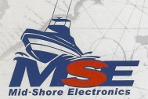
R&D Boat Supply Woolford Store Ferry Point Marina
22 Washington St. 1615 Taylor Island Rd. 1606 Marina Dr.
Cambridge, Md. 21613 Woolford, Md. 21677 Trappe, Md. 21673
410-228-0674 Edwin Bramble Jake Glover
443-521-4680 410-476-3304
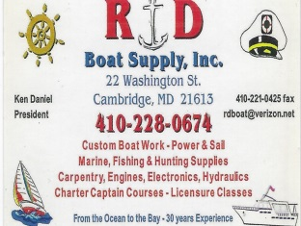 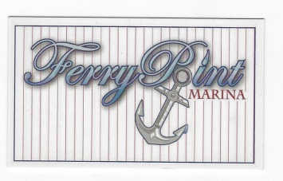

Chris Cianci Ed Cartwright
410-820-4070 484-280-7842

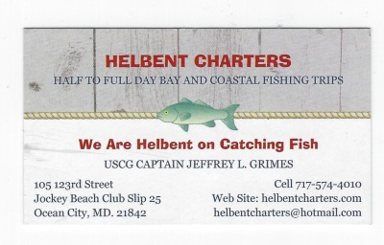

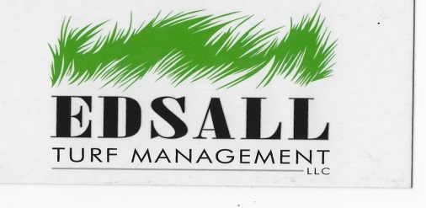 Edsall Turf Management
12519 Wetland View Ct.
Cordova Md. 21625
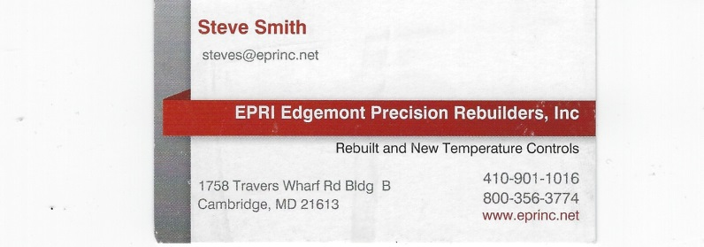
EPRI Edgemont Precision Rebuilders, Inc.
Steve Smith
1758 Travers Wharf Rd. Bldg. B
Cambridge, Md. 21613

Hook Removal
You should be able to highlight this link and click “open hyperlink” to view this short video. If that doesn’t work, copy and paste it to your browser. Might think about hook removal a little differently.
https://www.youtube.com/watch?v=G8LmxwOgBhA

