July 11, 2020
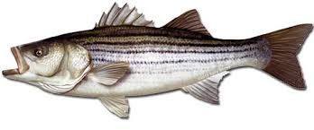
Mid-Shore Fishing Club

President – Tom Wilkison Reefball Coordinator – Bud Connors Vice President – Steve Schneider Scholarship Foundation – Steve Schneider Treasurer – Christy Helgason Raffles Committee –Don Rollyson
Webmaster – Bob Lawrence Club Fishing Tournaments Committee
Membership Committee –vacant – Chuck Prahl Christy Helgason Helmar Helgason
Guest Speakers – vacant Club Fishing Trips – vacant (looking for volunteer)
Flea Market – Harry Miller Tom Wilkison
Board Members- Tom Wilkison, Steve Schneider, Christy Helgason, Bob Lawrence, Harry Miller (n/v), Rob Feezer,
Steve Spellman, Rob Harding

NEXT MEETING July 16, 2020 7:00 PM at Elks Lodge #1272 Cambridge, Md. 21613

The Mid-Shore Fishing Club is dedicated to protect and preserve the rights and traditions of the recreational fisherman
Our last meeting was February 20, 2020 at the Elks Club. A lot has happened or not happened since that night.
We were able to have our Flea Market and it was a success. All our vendor tables were allocated and we had a greater public attendance than we have seen in the last few years. That was particularly encouraging as the rockfish season was up in the air at that time.
Since the flea market we had to not only cancel all subsequent meetings, but we cancelled our Wachapreague flounder tournament and our Kid’s Fishing Derby.
No doubt all of us will be thankful when Covid-19 is behind us. Everybody stay safe. All in all, the Eastern Shore has faired better than most. Lets keep it that way as we are seeing up/ticks around the country . The state of Maryland’s guidelines allow us to meet, as long as we practice “social distancing”. So, we are getting together Thursday, the 16th, 7:00 at the Elks club. If you are the least little bit sick, stay home. If you don’t feel good stay home.
Board Members Tom would like for board members to show up at the Elks Club at 6:00. We’ll have an informal board meeting as we set up tables and chairs. We’ll discuss our upcoming Clint Waters Memorial tournament and any other issues that might need to be discussed.
__________________________________________________________________________________________________
Dues…for those members who didn’t purchase dues for three years and/or whose dues expire 12/31/2019, its past time to update your membership. Dues are $15/year individual, $20/year/ family, $40/3 years /individual, and $55/3 years/ family. You can bring your payment to the meeting or you can mail a check (made out to Mid-Shore Fishing Club) to :
Mid-Shore Fishing Club
PO Box 514
Cambridge, Md. 21613

Our February 20th meeting was called to order at 7:00. We had 23 attendees. We discussed many issues including the upcoming Flea Market (who was helping set up, who was manning which table and who was helping disassemble when we were done). We discussed the Wachapreage tournament. It’s planning was top notch and it was set up to be a success. The fishing part, the Hotel part, the prizes, the calcutta’s were all worked out to perfection. All that is on the back burner and we’ll get back to it next year. The Kid’s derby was discussed, all in the beginning stages. We were looking forward to a bigger and better event this year. This is on the back burner as well.
Treasurer’s Report
An important treasurer’s report coming up, as we haven’t had one in over 4 months. Our treasurer, Christy, has keep the board up to date on its status. The Flea Market generated some income. We are fortunate we got it in when we did, as other fishing clubs had to cancel theirs. We have lost all monthly meeting 50/50 monies. There would have been some income generated by the Wachapreague Flounder tournament. We have not spent anything on the Kid’s Derby since it was canceled. That was close to $1000 expense, even with the very generous donations of some of our members and patrons/sponsors. We’ll learn more about the Clint Waters Memorial Tournament at our meeting Thursday.

Reef Balls
We have about a dozen reef balls already constructed. Right now there are two poured and two unusable at the concrete plant. The last four months with no activity have left our form foundations in need of attention. When we can safely work on them and get them back into shape we will do so, and will let the membership know when we need some help.
Rock the Choptank
Soon, we’ll have a conversation with Brett, Chris and the folks at Rock the Choptank and let you know where they are and what they are thinking about this years event. As of our last meeting, “Tournament organizers are considering limiting the number of boats, maybe prohibiting planer boards and possibly limiting catches per boat to only 1 fish over 28”. The thought is to steamline the tournament and to practice conservation principles. The 2020 event is scheduled for October 26th with home base at Long Wharf.”
Tournament Fishing
If you hear of a tournament that may be of interest to our members, let me know and I’ll spread the word via email.
Year Long Fishing Contest
Our 2019 year long drawing was held, and the winners were:
Steve Schneider 1st place $300
Chris Powell 2nd place $200
Steve Schneider 3rd place $100

Here are our 2020 entries to date:
White Perch 12 ¼” Chris Powell
Yellow Perch 12 ½” Steve Spellman
Sea Bass 23 ¾” Chris Powell
Snakehead 34” Chris Powell
Channel Cat 22 ¾” Joe Opalski
Crappie 13 3/8” Steve Schneider
Yellow perch 12 ½” Steve Spellman
Blue Gill 8 ½” Steve Schneider
Large Mouth 19 ½ “ Don Rollyson
Rockfish 47” Guy Edgar IV
Black Drum 42” Neal D’Adamo
Speckled Trout 17 7/8” Bob Lawrence
I know at least one of these entries has been out done, but you gotta’ send ‘em in. If there are any additions or corrections, please let me know.

Fishing Report
The last time we had a fishing report we were excited about yellow perch. Rock fishing has been good around Cambridge . Casting bucktails and jig heads with paddle tails have been successful. Mostly in shallow water around structure and early in the morning or late evening, near sunset. Speckled trout have been been caught near Todd Pt. and near Howell Pt. casting. Folks have been tearing up trout on the Honga with peeler, fishing on the outside edge of grass beds. Casting is tough because of all the cow-nose rays. We hear the cobia fishing is good in Virginia waters. Lenny Rudow is talking about trolling for Spanish mackerel in the bay. We’ll pass on first hand reports as we get them
Club Fishing Trips
We are still looking for someone to step up and organize club trips. Steve Schneider set up a seabass trip which was a hoot. Went really well with most folks masked and safe. He set a few cobia trips later this year. Everyone that wanted to go is going. The trips are full at this time. If anyone cancels, I’ll let the membership know .
Last newsletter I sent out some special thoughts to Captain Jeff Grimes / Hellbent Charter as he battles some medical issues. Capt. Jeff got us started raffling off fishing trips to benefit our scholarship fund and it looks like the concept will be around for a while. I talked to Jeff today, he’s in good spirits, hanging in there, and not going any where. Jeff, we wish you the best.
Our own Harry Miller has spearheaded this scholarship effort on our end. Snakehead trip raffle this November.
Guest Speakers
Last February’s speaker was CL Marshall. CL gave a lively presentation talking about speckled trout, red drum and cobia. I captured a quote from CL “a little something going on that way”, talking about speckled trout on the Honga. That sure turned out to be true. I know of a few of our members who were listening.
This month’s speaker is Bob Baker from Seaford. Bob had a guide service and a hook & line liscense. He’s been fishing for flounder for over 50 years. He’s seen every kind of rig that’s ever been made…driven the back roads so he wouldn’t get weighed, excuse me, I went some where else. He’s seen every kind of flounder rig that’s ever been made and decided to make something better. Next Thursday he will show them to us, along with talking about knowing the water, knowing your rod set up, and know what your tackle should look like in the water. “if you can’t see the skeg of you motor, you won’t be catching many flounder.
Upcoming Events
July 16th meeting 7:00 at the Elks Club
August 6th Thursday Luncheon at Elks Club Pavilion (byo lunch)
September Clint Waters Memorial Tournament??
October 26th Rock the Choptank
Sponsors and Patrons
As you may or not know, our Sponsorships and Patronages are for one year and expired December 31st 2019. We’ll be sending letters out to these and other folks shorty, hoping we can continue our relationships and create new ones. Here are the folks that supported us last year and I believe we supported them as well. A heartfelt thanks to you all and hopes for a prosperous and successful 2020.
I will continue to post our sponsors and patrons who haven’t re upped in are newsletter and our website for a short period of time.

Sponsors

Island Tackle Outfitters Joe Camp Tom & Debbie Cohee
1915 Main st. 5613 Riverton Rd. Easton Md.
Chester, Md. 21619 Cambridge, Md. 21613
Dave Tolbert
410-643-4099
Windy Upholstery & Canvas
Cambridge, Md. 21613
Mark Windmiller
410-221-0981
Barry Vickers (In memorium) J&L Services
512 Regency Dr.
Salisbury Md. Seaford De. 1997

Patrons

Composit Yacht Mid-Shor Electonics BlueWater Marine
1650 Marina Dr. unit A 205 Trenton St. 5469 Moose Lodge Rd
Trappe, Md. 21673 Cambridge, Md. 21613 Cambridge, Md. 21613
Martin Hardy 410-228-7335 410-228-0000
c 443-521-4422
off 410-476-4414
R&D Boat Supply Woolford Store Ferry Point Marina
22 Washington St. 1615 Taylor Island Rd. 1606 Marina Dr.
Cambridge, Md. 21613 Woolford, Md. 21677 Trappe, Md. 21673
410-228-0674 Edwin Bramble Jake Glover
443-521-4680 410-476-3304
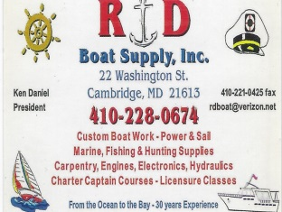 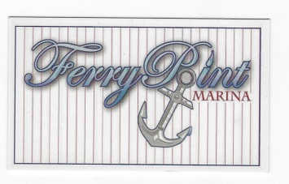

Chris Cianci Ed Cartwright
410-820-4070 484-280-7842

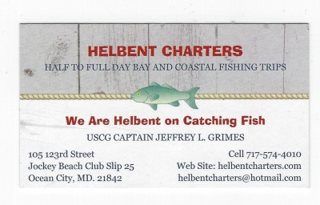

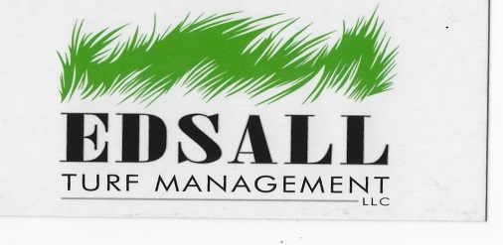 Edsall Turf Management
12519 Wetland View Ct.
Cordova Md. 21625
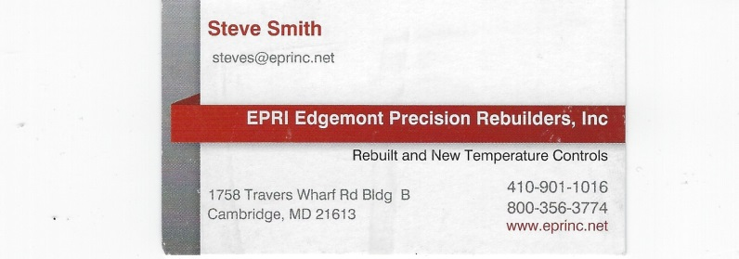
EPRI Edgemont Precision Rebuilders, Inc.
Steve Smith
1758 Travers Wharf Rd. Bldg. B
Cambridge, Md. 21613
Tom Wilkison photo…I took the liberty of naming it
“Couple of Keepers”

