December 10, 2020
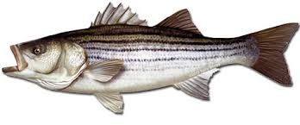
Mid-Shore Fishing Club

President – Tom Wilkison Reefball Coordinator – Bud Connors Vice President – Steve Schneider Scholarship Foundation – Steve Schneider Treasurer – Christy Helgason Raffles Committee –Don Rollyson
Webmaster – Bob Lawrence Club Fishing Tournaments Committee
Membership Committee –vacant – Chuck Prahl Christy Helgason Helmar Helgason
Guest Speakers – vacant Club Fishing Trips – vacant (looking for volunteer)
Flea Market – Harry Miller Tom Wilkison
Board Members- Tom Wilkison, Steve Schneider, Christy Helgason, Bob Lawrence, Harry Miller (n/v), Rob Feezer,
Steve Spellman, Rob Hardy

NEXT MEETING December 17, 2020 7:00 PM at Elks Lodge #1272 Cambridge, Md. 21613

The Mid-Shore Fishing Club is dedicated to protect and preserve the rights and traditions of the recreational fisherman
__________________________________________________________________________________________________
A membership application/renewal is attached to this email along with this newsletter
Dues…for those members who didn’t purchase dues for three years and/or whose dues will expire 12/31/2020, its past time to update your membership. If you just got dues for one year they are about to expire, December 31, 2020. Dues are $15/year individual, $20/year/ family, $40/3 years /individual, and $55/3 years/ family. You can bring your payment to the meeting or you can mail a check (made out to Mid-Shore Fishing Club) to :
Mid-Shore Fishing Club
PO Box 514
Cambridge, Md. 21613
Keep in mind, our fiscal year is January 1st through December 31st. If your dues are paid up you are eligible for our club subsidized fishing trips. We had 8 this year so far, 1 seabass trip, 3 rock fish trips, 1 yellow perch/pickerel/crappie trip and 3 cobia trips. We will have more next year. We want to get a couple more rockfish trips in like we used to. If dues are up to date you can participate in our “Year Long Contest”, you are eligible for our Christmas dinner, which the club picks up a large part of the tab. Your dues help support our “Kid’s Fishing Derby” and our Scholarship fund. We make an effort to get some really good speakers and folks have been really goods at that. We build reefballs for deployment in Maryand waters and dues help to support that effort. Folks, $15 ain’t squat for all that and more. It sure makes it easier on all of us if you pay your dues at the beginning of the year and try to stay up to date.

Our November 19th meeting was called to order. There we 14 attendees.

Fishing Report
The season for harvesting rockfish ended today. Catch and release is still permitted until December 31st. The DNR fishing report is done until March. A few folks went out today, but nothing to report. It seems the rock are following the bait fish down toward Virginia and the perch are going to deeper, warmer water.
Club Trips
As you know we’ve had 8 subsidized club fishing trips. The last was in November with Guy Edgar aboard “Drag n Deep”. After a late scratch, the angling crew was down to five folks. The left Ragged Point, went around Cook’s Point and trolled the area around Marker #10 and the mouth of the Choptank. They picked up a few small fish, no keepers. After talking to some captains across the Bay, they headed toward Parker’s Creek. They picked up a few keepers, but no monsters. Report was a good time was had by all and “great to be out there”.
Treasurer’s Report
Our accounts are in good shape. Come to the meeting (CTTM) to get an accurate and up to date report.
Reef Balls
Bud and Bob went to the concrete plant today and stripped reef balls that had been poured. Channey Enterprizes has been doing a good job making the pours. They are only using concrete with pea gravel as the aggregate. This makes for the best reef balls for our efforts. We have altered our procedures a little. When attaching the smaller inflatables to the forms we utilize small wooden wedges to keep them tight against the form walls . This helps keep the portals uniform, clean, and open to the center of the ball. We have altered our final assemble method. We have half the form secure with 2 small inflatable and the large inflatable in place and then pivot the other half of the form (with inflatables) in place. We then pin the forms together, inflate the large ball and wait for the pour. Since using this method and the plant only pouring with pea gravel, every reef ball has been strong and has the appropriate appearance. We now have 29 units with 4 ready to pour. Bud gave the guys at Chaney some gift certificates to Dunkin Donuts for a job well done.
50/50 Winners
John Bryde and Steve Spellman were this month’s winners
Tournament Fishing
If you hear of a tournament that may be of interest to our members, let me know and I’ll spread the word via email.
Year Long Fishing Contest

Here are our 2020 entries to date:
White Perch 12 ¼” Chris Powell
Yellow Perch 12 ½” Steve Spellman
Sea Bass 23 ¾” Chris Powell
Snakehead 34” Chris Powell
Channel Cat 22 ¾” Joe Opalski
Crappie 14 “ Guy Edgar IV
Yellow perch 12 ½” Steve Spellman
Blue Gill 8 ½” Steve Schneider
Large Mouth 19 ½ “ Don Rollyson
Rockfish 47” Guy Edgar IV
Black Drum 42” Neal D’Adamo
Speckled Trout 23 7/8” Tobey Frey
Cobia 561/2”” Chris Powell
Red Drum 47” Chris Powell
Flounder 23” Chris Powell
Ribbon fish 42” Guy Edgar IV
Spanish Mackerel 23 ½” Bobby Shenton
Blue fish 21 7/16” Tobey Frey (photo not posted on website)
Sheepshead 14.1 lb. Daniel Mastronardi Jr.
Kingfish 13 1/8” Bobby Shenton
Pompano 7 ¾” Steve Spellman
Lizardfish 14 ¼” Bobby Shenton
As you can see highlighted in red, there was one change since last month. Guy Edgar IV caught a 14” crappie. Nice Crappie Guy. Sorry Steve.
. 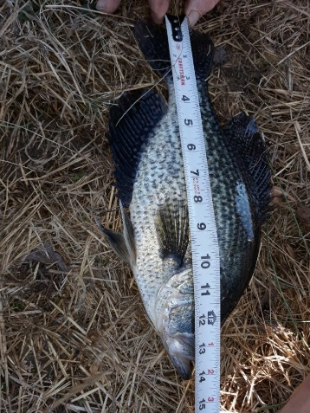
There was almost another upset as Brad Foxwell caught a 44 ¾” rock.

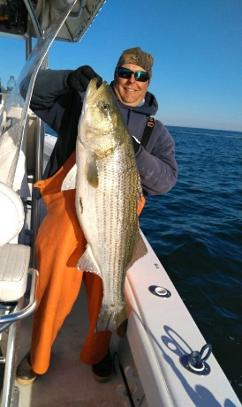
Photos of all fish are available on our website www.mid-shorefishingclub.com look in photo gallery
Our Year long contest ends at midnight December 31st. You still have time to enter some nice fish. If there are any additions or corrections, please let me know. We’ll have our drawing at our January meeting, 1st place $300, 2nd place $200 and 3rd place $100.
Snakehead Trip Raffle
Our snakehead raffle was won by Hazel Burt. Hazel and her husband Jim are one of our sponsors, J&L Services in Galestown.
Scholarship Fund
The Snakehead Raffle benefits our scholarship fund. Soon we’ll have a report as to how we did. Some time in the near future the University of Maryland will select our 2021 Clint Waters Memorial Scholarship recipient. Certainly, we’ll let you know who that is and when it happens. We’ll try to arrange a time when all of us can meet our newest recipient
Guest Speakers
This month’s speaker is club member Brett Dean. Brett is one of the organizers of “Rock the Choptank”, a local fishing tournament that is enormously successful and becoming more popular each and every year. Brett will present a check to the club, which are proceeds from the MSFC Calcutta. The Rock the Choptank folks administer this Calcutta,and anyone fishing in the tournament can participate if they choose. It is a generous benefit to Mid Shore Fishing Club. Brett is going to talk about the tournament, its winners and prizes that were awarded. Brett has the Farmers Insurance Agency in Cambridge. He will answer any questions you might have about marine insurance, or any other insurance for that matter. Brett handles our event insurance for our Flea Market and for our Kid’s Fishing Derby
Upcoming Events
December 17th meeting at the Elks Club
January 7th Luncheon at Riverview at the Point
Flea Market… April 17th
Kid’s Fishing Derdby… shooting for 1st week in August
Flea Market
Our flea market is scheduled for April 17th. Because of covid restriction uncertainties, we may have it out side. We’ll make that call (in or out ) a little later. If we decide to have it outside we’ll use April 24th as a rain date.

Sponsors and Patrons
As you may or not know, our Sponsorships and Patronages are for one year and are about to expire December 31st 2020. We’ll be sending letters out to these and other folks shorty, hoping we can continue our relationships and create new ones. Here are the folks that supported us last year and I believe we supported them as well. A heartfelt thanks to you all and hopes for a prosperous and successful 2021.

Sponsors
Island Tackle  1915 Main St.  Chester MD 21619  410-643-4099 | Joe Camp  5613 Riverton Rd.  Cambridge, MD 21613 | Tom & Debbie Cohee  Easton, MD
Windy Upholstery & Canvas  Cambridge, Md. 21613  Mark Windmiller  410-221-0981 | J&L Services  (Jim & Hazel Burt )  General Contractor  Galestown Md 21659  410-943-3355 | Barry Vickers (In memorium)  512 Regency Dr  Salisbury Md.

Patrons

Composite Yacht  1650 Marina Dr. Unit A  Trappe, MD 21673  Martin Hardy  cell 443-521-4422  office 410-476-4414 | Mid-Shore Electronics  205 Trenton St.  Cambridge, Md. 21613  410-228-7335  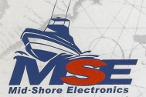 | Blue Water Marine  5469 Moose Lodge Rd  Cambridge, Md. 21613  410-228-0000
R&D Boat Supply  22 Washington St.  Cambridge, MD 21613  410-228-0674  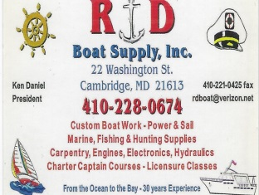 | Woolford Store  1615 Taylor Island Rd.  Woolford, MD 21677  Edwin Bramble  443-521-4680 | Ferry Point Marina  1606 Marina Dr.  Trappe, MD 21613  Jake Glover  410-476-3304  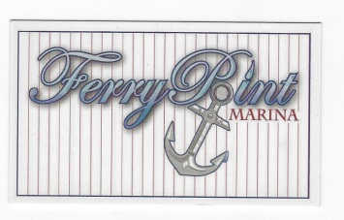
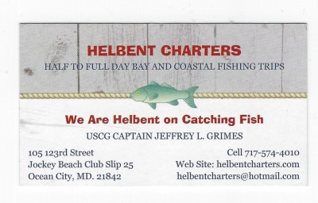 | Chris Cianci  410-820-4070 | Ed Cartwright  484-280-7842
EPRI Edgemont Precision Rebuilders, Inc.  Steve Smith  1758 Travers Wharf Rd. Bldg. B  Cambridge, Md. 21613  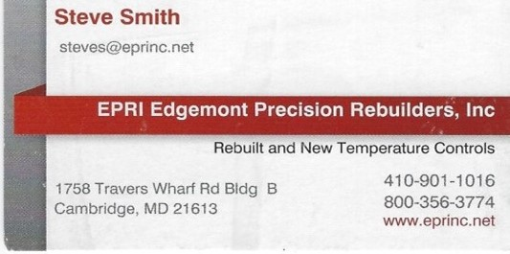 | Edsall Turf Management  12519 Wetland View Ct.  Cordova, MD 21625 | 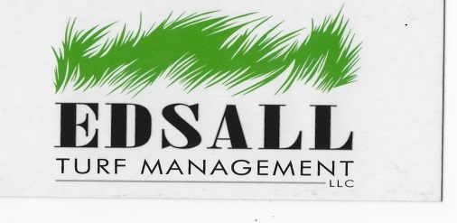

Maybe Not So Funny
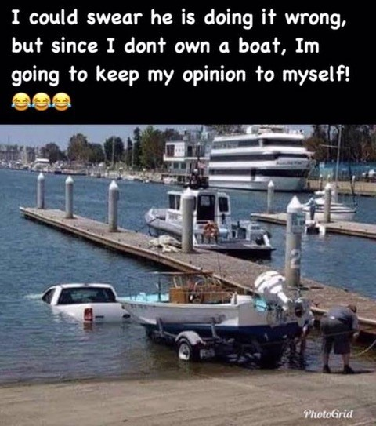
Stay Well Stay Safe

